**Bug ID**: UI-NAME-001

**Title**: Product name includes parentheses and programming-like syntax that may cause confusion

**Description**: The product name uses programming syntax that may confuse users and disrupt test automation. A clearer name would improve readability and presentation.

**Steps to Reproduce:**

1. Login to the SauceDemo website using valid credentials.
2. Navigate to the Products page.
3. Locate the product titled **"Test.allTheThings() T-Shirt (Red)"**.

**Expected Result**: Product name should be written in clear, user-friendly language without using programming syntax that could be misinterpreted or cause rendering issues.

**Actual Result:** The product name includes a dot notation and parentheses, resembling a function call in code (Test.allTheThings()), which may be misinterpreted by developers, testers, or automated systems parsing product data.

**Environment**:

* Browser: Chrome 124.0
* OS: Windows 11
* URL: https://www.saucedemo.com/

**Severity**: Low (Cosmetic/ UI but may affect readability and test parsing)

**Attachments**:

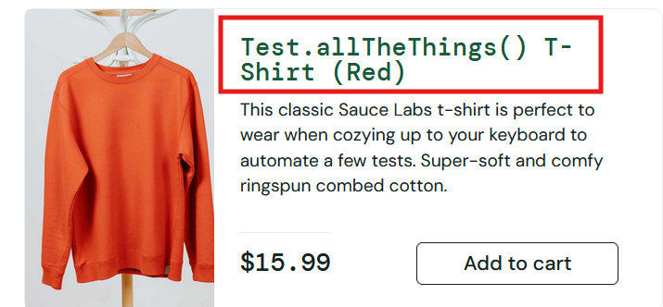

**Reported By**: Muhammad Salah

**Date**: 21-7-2025

**Status**: Open

**Bug ID**: UI-CART-002

**Title**: User cannot add more than one of the same item to the cart

**Description**: User can only order one item from each product, no control over the quantity of the products ordered

**Steps to Reproduce:**

1. Login to the SauceDemo website using valid credentials.
2. Navigate to the Products page.
3. Click “Add to Cart” for any product (e.g., Sauce Labs Backpack).
4. Navigate to the cart and observe the item quantity.

**Expected Result:** Users should be able to increment or decrement the number of identical items in the cart—either from the product page or within the cart itself.

**Actual Result:** The cart allows only one unit of each product. No controls are available for increasing quantity or specifying how many units a user wishes to purchase.

**Environment**:

* Browser: Chrome 124.0
* OS: Windows 11
* URL: https://www.saucedemo.com/

**Severity**: Low (Functional/UI, but impacts user expectations and basic shopping behavior)

**Attachments**:

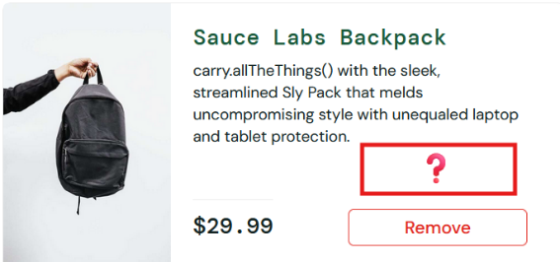

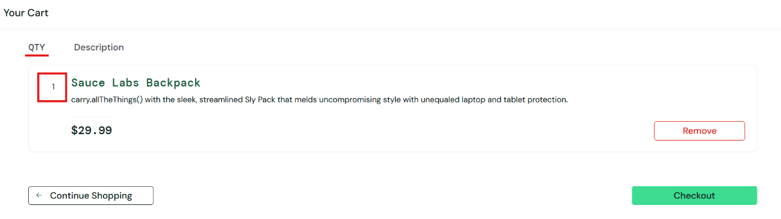

**Reported By**: Muhammad Salah

**Date**: 21-7-2025

**Status**: Open

**Bug ID**: ORDER-EMPTY-003

**Title**: User can complete checkout and submit an order without adding any items to the cart

**Description**: The SauceDemo website allows users to proceed through the checkout workflow and complete an order—even when the cart contains no items. This leads to invalid order records and contradicts basic e-commerce logic.

**Steps to Reproduce:**

1. Login using valid credentials
2. Navigate directly to the cart page without adding any items
3. Click “Checkout”
4. Enter valid customer details
5. Click “Continue” and then “Finish”

**Expected Result:** System should prevent checkout if cart is empty and display an appropriate error message (e.g. “No items in cart”).

**Actual Result:** Order is processed successfully, even though no items were selected.

**Environment**:

* Browser: Chrome 124.0
* OS: Windows 11
* URL: https://www.saucedemo.com/

**Severity**: Medium (Functional flaw that allows invalid transactions)

**Attachments**:

Bug video link: <https://drive.google.com/file/d/1pYthiThgpIJTCDqxeloFqeY878yUGyWe/view?usp=sharing>

**Reported By**: Muhammad Salah

**Date**: 21-7-2025

**Status**: Open